Tugas Praktikum 2 Pemrograman Web Lanjut

Nama : Yofandra Arta Priyoga

Kelas : 2G

Absen : 29

NIM : 2141720121

Praktikum 1

1.

2.

Praktikum 2

Praktikum 3

1.)

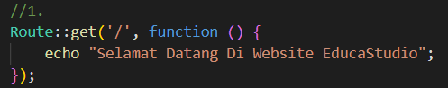

2.)

3.)

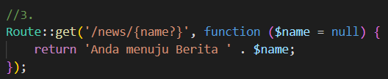

4.)

5.)

6.)

